

SMART CITIES

Open Data for Urban Planning

Louisa Ong

Cover Page

# Understanding the Impact of Gentrification on Non-Gentrified Neighborhoods with Brooklyn Crime Data

Professor Michael D. Parrott  
Professor Elena Krumova

Master of Arts Thesis

Columbia University QMSS

15 May 2020

Table of Contents

Understanding the Impact of Gentrification on Non-Gentrified Neighborhoods with Brooklyn Crime Data 1

1. Introduction & Rationale 4

1.1 Smart Cities: Open Data for Urban Planning 4

1.2 Research Question 5

1.3 Gentrification and Crime 6

1.4 Neighboring Non-Gentrified Areas 6

1.5 Case Study: Brooklyn 7

2. Analytical Approach 9

2.1 Definition & Concepts 9

2.2 On Brooklyn 11

2.3 Non-Gentrified Neighborhoods 13

2.4 Hypothesis 15

3. Data & Methodology 16

3.1 Datasets Imported 16

3.2 Independent Variable: Gentrification 19

3.3 Dependent Variable: Brooklyn Felony Crime Rate 20

3.4 Time Frame: 2010 - 2018 21

3.5 Control Variables 21

3.6 Methodology 22

4. Results 27

4.1 Regression Models 27

4.2 Cross-Lagged Model Analysis 30

4.3 Choropleth Maps 31

4.4 Spatial Autocorrelation Analysis 37

5. Discussion 41

5.1 Significance of Results for Gentrification on Crime 41

5.2 Understanding Outliers 43

5.3 Limitations of Research 44

6. Conclusion 47

7. References 49

# Introduction & Rationale

## Smart Cities: Open Data for Urban Planning

As 68% of the world’s populations are expected to live in cities by 2020 (United Nations, 2018, p. 21), the concept of “Smart Cities” was developed as a solution to existing urban planning issues to provide a better quality of life for all citizens. Essentially, the idea behind Smart Cities is to integrate Information and Communication Technologies (ICT) to tackle critical issues relating to cities (OECD, 2017, p. 77). It is a term that is a fusion of ideas and policies and can be understood as a futuristic approach to make cities more efficient, sustainable and livable. These can involve the public sector, the private sector, educational institutions, and an ordinary data science student.

Many municipalities and private corporations around the world have raced to develop projects and systems to around this topic, which has sparked considerable interest. Open Data is an example of one of the possible initiatives under the umbrella of Smart City projects. High quality Open Data entail raw, public data that can be freely used by anyone. Several municipalities do provide public data on their platforms, but the quality of such Open Data is what distinguishes them from others. What is the sample size of the datasets? How many years of data gets published? Is the raw data published, or only the polished findings? These are the questions that researchers would ask while considering whether a dataset would be useful.

Investment into maintaining a rich statistical database and a platform for sharing this data would require a significant amount of resources and political will, undoubtedly. Still, Open Data does seem to be the backbone to developing “Smart Cities” and this research paper seeks to illustrate how Open Data can be beneficial for Urban Planning.

## Research Question

This paper will involve **Using Brooklyn Crime Data to Understand the Impact of Gentrification in Non-Gentrified Neighborhoods**. It consists of extracting the available data on Brooklyn from sources such as the U.S. Census Bureau and New York Public Safety Department and exploring how the borough has evolved overtime.

The data on Gentrification and Crime originate from different data sources but this is an example of where the benefit of Open Data becomes evident – citizens get to independently scrutinize public data and find novel ways to analyze existing information. While demographic and commercial data on Non-Gentrified Neighborhoods in Brooklyn such as Canarsie and Bay Ridge to understand the social well-being of residents in these areas may be less abundant, crime report data is relatively available consistently throughout New York City. As such, a comparison between the two variables of gentrification and crime could shed light on the impact of gentrification for residents in neighborhoods that have not yet experienced gentrification.

Such information would then especially be useful for urban planning. Gentrification is a hot topic for debate and people tend to harbor strong feelings towards this development, with mixed opinions. The true impact of gentrification is unclear as it is experienced over a long period of time and it is also subjective – some would say that cultural preservation is vital while some would prefer modernization. For this paper, Crime is a variable that is more straightforward, in that most people would agree that having less crime is better, so at least that will be clear for this paper. Whatever it is, more insight on the impact of gentrification would help inform decisions of future projects that will involve gentrifying old neighborhoods not just in Brooklyn but elsewhere in the world. Furthermore, while it is understandable that gentrification may not always be avoidable, perhaps research could be useful for relocating residents as well.

## Gentrification and Crime

The relationship between the two main variables of Gentrification and Crime for this paper have been explored by a number of researchers. Arthur O’Sullivan’s 2005 paper “Gentrification and crime” published in the Journal of Economics consisting of a case study on Portland, Oregon was one of the first few studies on this topic (O’Sullivan, 2005). He noted that Gentrification leads to more high-income agents in the city and displaces low-income agents, which decreases the crime rate. Similarly, a case study on Cambridge, Massachusetts revealed that the city crime rate dropped by 16% in gentrified areas (Autor, Palmer, Pathak, 2017). There is a strong relationship between gentrification and lowering crime rates, but current studies mostly focus on the areas that have been gentrified.

## Neighboring Non-Gentrified Areas

Unlike the previously cited studies, the focus of this paper would be on non-gentrified neighborhoods. These neighborhoods are not often studied (Yee, 2015), perhaps because research interests tend to correspond to economic activity and because less data is available. Investigating these areas would bring further insight into the impact of gentrification. While the gentrified areas have undergone significant change that can be measured by several metrics (rent, income, social demographic), the effects of this change, namely the displacement of existing residents, would spill over to the neighboring non-gentrified neighborhoods. Often, the existing residents in gentrified areas would move somewhere nearby, further into the non-gentrified areas, as in the case of Brooklyn, New York (Lees, 2003, p. 2492).

Using data that is available somewhat consistently throughout the city, it is possible to get an insight to how non-gentrified areas have been impacted as a result of changes in neighboring areas that are undergoing gentrification. In this way, it is possible to consider both the impact of gentrification in gentrified neighborhoods and non-gentrified neighborhoods since the effects are more widespread than one would think.

## Case Study: Brooklyn

In this paper, Brooklyn, also known as Kings County, will feature as the setting for the analysis. While gentrification, disruptive urban planning and such social changes have occurred in the entire municipality of New York City and in other cities of the world, what Brooklyn has experienced is more focused and unique (Lees, 2003).

This borough of New York City has undergone extensive cycles of gentrification since the 1990s but still has neighborhoods which have not experienced gentrification. Furthermore, while many original residents were displaced, they remained within the boundaries of Brooklyn (Yee, 2015). Using supporting literature of Gentrification taking place in Brooklyn, Loretta Lee’s paper on the super-gentrification process of Brooklyn Heights describes qualitatively the concept of both gentrification and super-gentrification (Lee, 2003). Clearly, this is an area that has undergone a thorough extent of gentrification and in certain areas, multiple phases of gentrification. In fact, she even recounts the Third-wave Gentrification process (Lee, 2003, p. 2490) and this phase had occurred back in the 1990s.

Having such extensive gentrification occur in this borough does indicate that this is one of the most consequential change in the socio-economic environment of the area. This means that other factors, such as the immigration of low-income residents, which could impact this area and Brooklyn’s crime rates would not be as influential as gentrification. In other words, there is less noise upon the analysis of how crime rates in non-gentrified areas change.

Furthermore, since Brooklyn is a large county where some parts are undergoing gentrification and others are not, the impact of gentrification on less-gentrified neighborhoods would not be completely lost and would in fact be relatively contained and evident within the geographical area of the county.

All in all, these characteristics of Brooklyn affirm that this county would be an ideal borough, not just within New York City but also for other cities, to carry out a longitudinal geographic study on how Gentrification has affected Crime in the areas that have not yet been gentrified.

# Analytical Approach

## **Definition & Concepts**

### 2.1.1 Gentrification

**At its most fundamental, the sociologist, Ruth Glass, is quoted to have come up with the term Gentrification to describe the changes in neighborhood, be it from income levels,** racial demographics, displacement of long-term residents, increase in commercial activity, etc. (Smith, 1998, p.198).

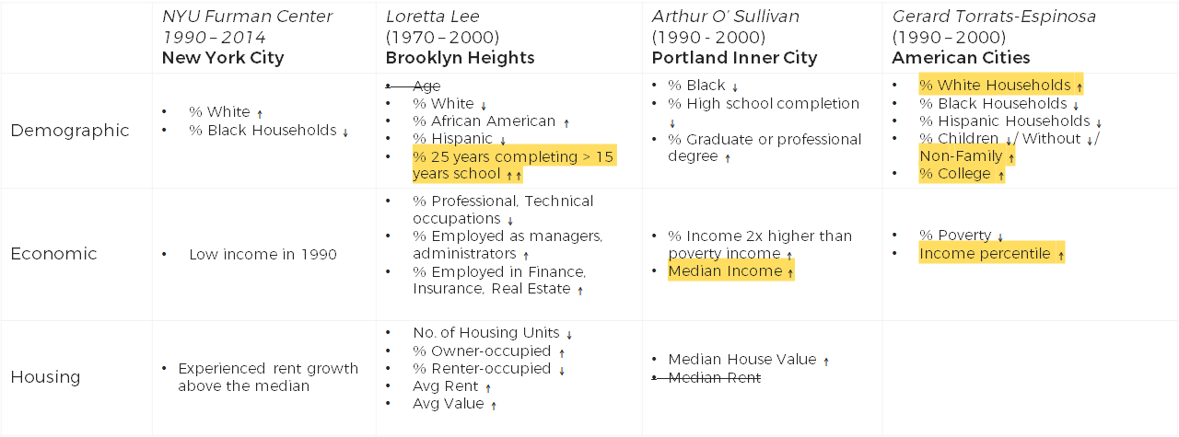In quantitative studies, researchers have interpreted gentrification through an informed amalgamation of several quantitative variables. While there is no single quantitative definition of gentrified areas, understanding how several papers have characterized these will be helpful. The different ways that is done is shown below in Fig. 1.

Figure 1. Different metric useds to define gentrification in existing research

The above studies first identified areas that have been gentrified, then sought to further understand the characteristics of these areas. The NYU Furman Center discerned the gentrified neighborhood in New York City using rent growth above the median, while Espinosa’s research on American cities used a census tract’s relative change in median income. Arthur O’ Sullivan’s study on Portland’s inner city evidenced gentrification through income mixing and racial mixing and Loretta Lee’s study on super-gentrification was focused directly on the neighborhood of Brooklyn Heights. While these are relevant, they do not qualify the extent of gentrification, as it simply identifies areas that are gentrified.

However, what these all have in common and can be useful is that as the studies proceeded to characterize the gentrified areas, the changes in other metrics were distinct and similar. In Fig. 1, the change in variables that were studied is shown by an increase in decrease, meaning that there was an increase in white households, increase in those completing 15 years of school, an increase in income, increase in non-family households, fewer black households, etc. Some variables were inconclusive and some are variations of one another but the common domains that characterize gentrification include: race (increase in white), education (more residents with higher levels of education), household type (increase in non-family households), income (relative increase in income).

What would be more appropriate for the study is the Los Angeles Index of Neighborhood Change which maps gentrification by indices of neighborhood change (Pudlin, 2016). It is a web application by the Los Angeles Innovation Team which indicates the level of gentrification for a neighborhood based on an aggregate of the metrics of rent, education level of residents, household income, household type and race (Cohen, Pettit, 2019). These correspond to the characteristics identified by the previous studies, and it would be based on this index that gentrification in Brooklyn would be measured.

### 2.1.2 Crime

**When it comes to crime, there are also many categories of crime to consider – Felony Assault, Robbery, Burglary, Rape, Manslaughter, Larceny, etc. On the extreme end would be violent crime, which is explored in the paper by Patrick Sharkey and Gerard Torrats-Espinosa, “The effect of violent crime on economic mobility”** (Sharkey & Torrats-Espinosa, 2017, p.22)**, highlighting that low rates of upward mobility coincides with high rates of violent crime, based on longitudinal data.**

**In the dataset from New York Police Department (NYPD), offenses are classified into Felony, Misdemeanor, Violation. Similar to Sharkey and Torrats-Espinosa’s paper, this paper would consider the more severe types of crime since it, based on this literature, seems significant to other aspects of society like socio-economic inequality. Specifically, crimes categorized as a Felony would be used. This category of crimes is defined by NYPD as “a crime that is punishable by a term of imprisonment for more than one year” and include several sub-categories such as homicides, grand larceny, intoxicated driving, kidnapping, rape, robbery, theft-fraud, sex crimes, prostitution, possession of stolen property, gambling, forgery, felony assault, dangerous weapons, dangerous drugs, child abandonment, burglary, arson, abortion and other non-classified crimes. (NYPD, 2020). By considering only the graver crimes, it is likely that underreporting would be lower since these are more conspicuous than less severe crimes classified as Misdemeanor or Violation.**

## **On Brooklyn**

Examining the level of gentrification and its impacts in Brooklyn would require us to divide Brooklyn into parts. This can happen through neighborhoods, ethnic enclaves, census tracts, census blocks, police precincts, zipcode, etc. Upon conducting an exploratory data analysis on the data by census tracts and by neighborhoods as shown in the boxplots below (Fig 2.1, 2.2), the higher number of anomalies for the data separated by tracts indicate a lot of noise. This can be explained by how the tracts are too small in granularity, and the social demographic metrics per capita used would not reflect the information needed. As such, analyzing the data by neighborhood would prove more fruitful.

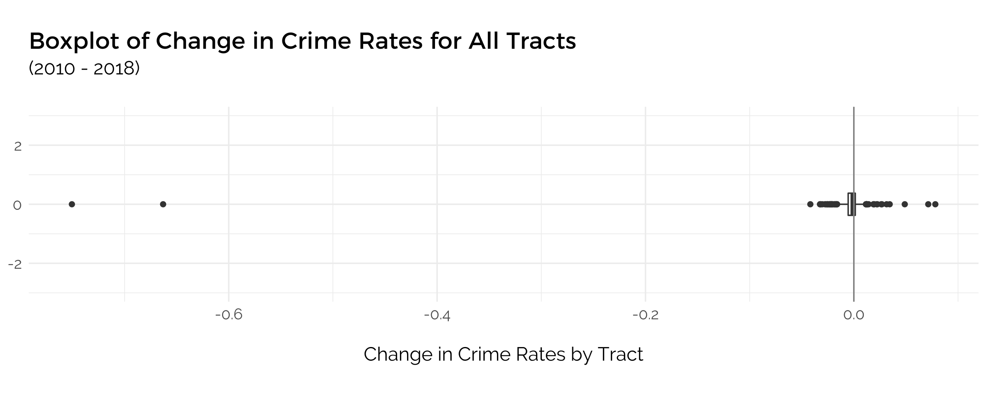

Figure 2.1: Boxplot digram of the Change in Crime Rates for All Census Tracts

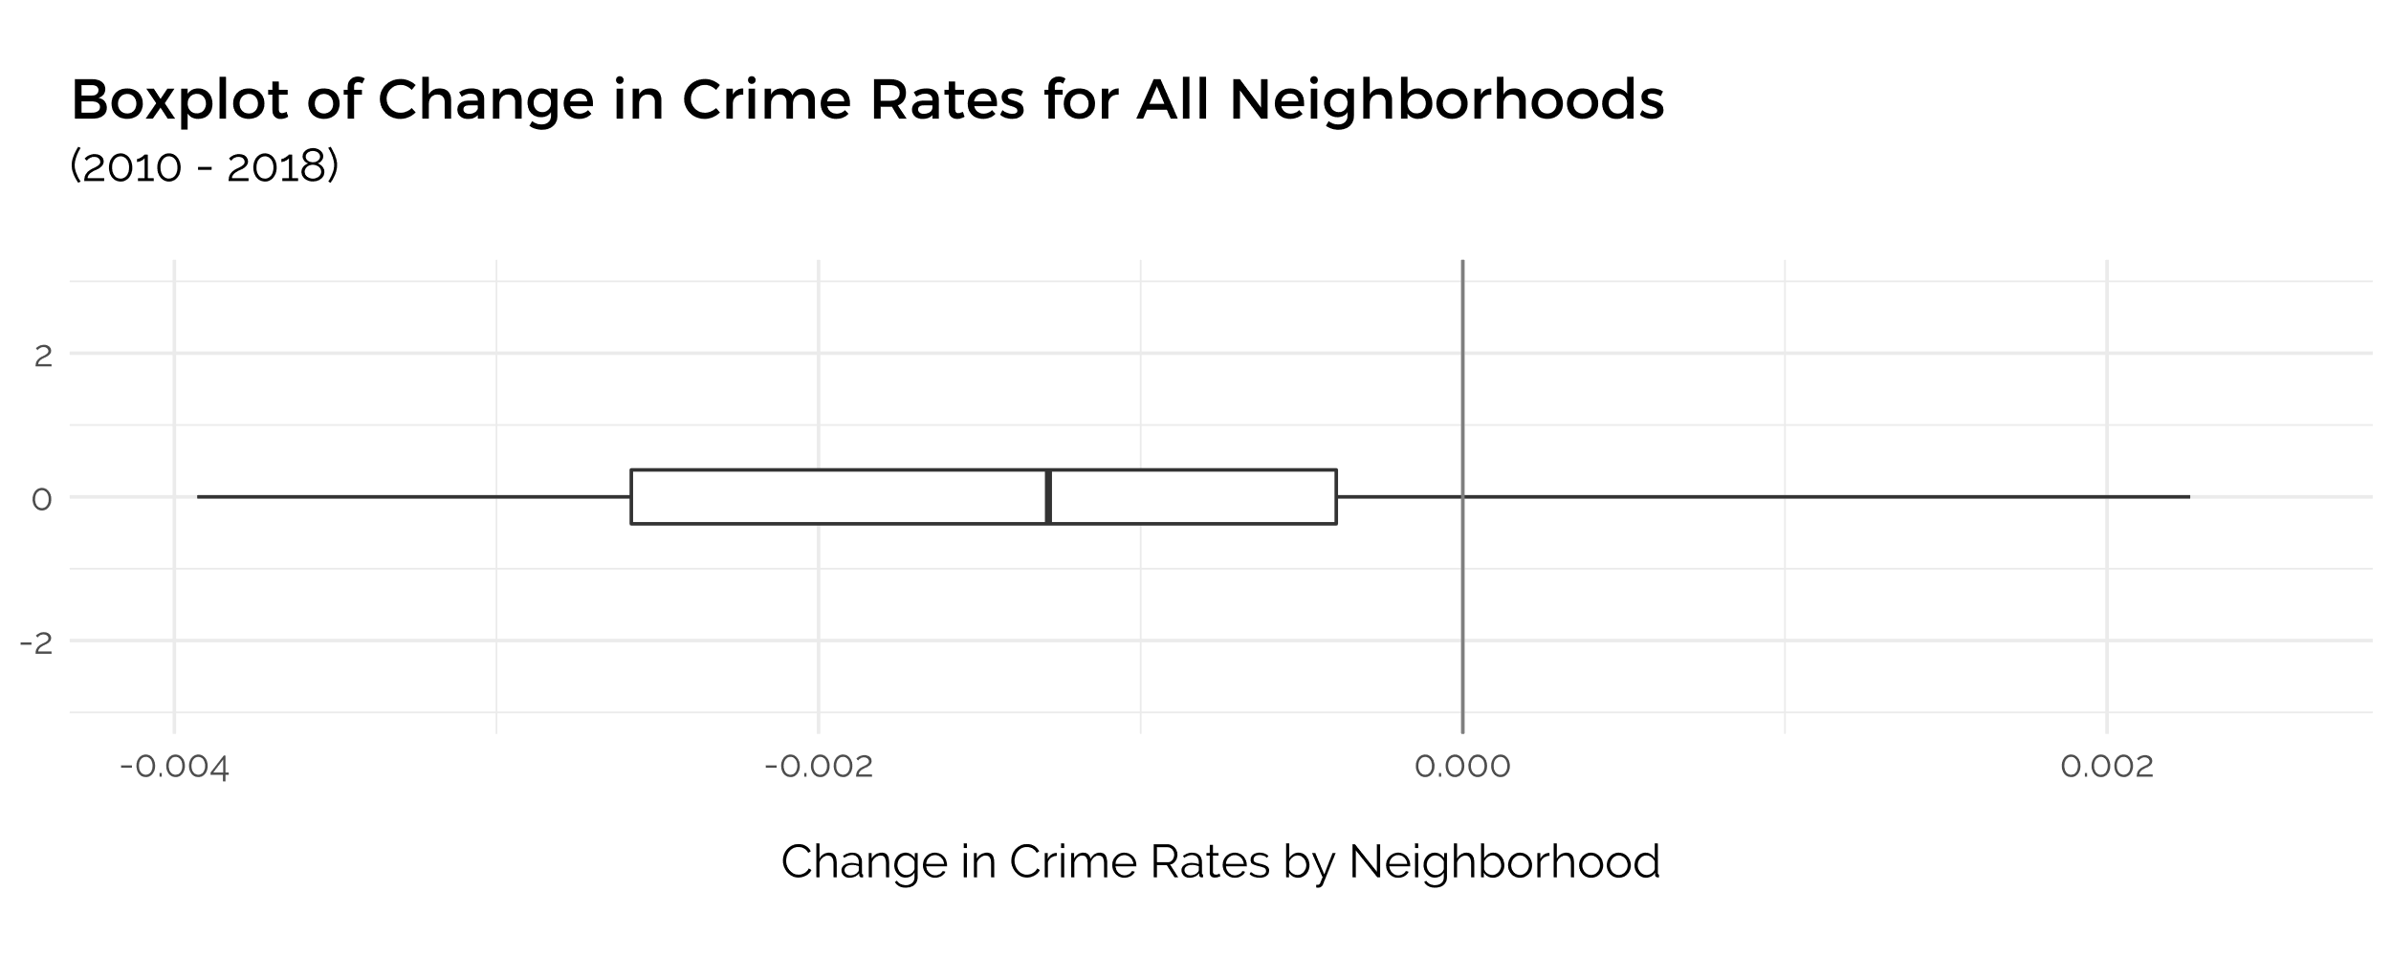

Figure 2.2: Boxplot digram of the Change in Crime Rates for All Neighborhoods

In Brooklyn, there are 50 neighborhoods, delineated by U.S. Census Bureau and named as “Neighborhood Tract Areas”, which is a reasonable quantity to compare one from the other and at the same time, it is plentiful enough to identify any variation present across the neighborhoods. Furthermore, since the impact of gentrification on non-gentrified areas is not something that distinct, and since the metrics used are calculated as per capita, any increase in granularity would only generate more noise and compromise the analysis, as shown in the boxplot. Finally, neighborhoods also have recognizable, known names such as Brighton Beach, Madison, Bushwick North, Bedford, etc., which makes inference more intuitive and referencing more practical, as compared to a numeric ID such as Tract No. 728.

## Non-Gentrified Neighborhoods

Figure 3: Text Scatterplot of all Neighborhoods by Gentrification Score and Change in Felony Crime Rate

Based on another exploratory data analysis with the constructed Gentrification Index over the period of 2010 - 2018, about half the neighborhoods in Brooklyn have a positive gentrification score and the other, a negative gentrification score, as observed in Fig. 1. A simple cross-reference to the areas that are known to be gentrified, such as Bushwick and Bedford, and those that are not, such as Bath Beach and Bensonhurst West, verifies that the Gentrification Index has a degree of validity. Hence, this research can be framed to consider neighborhoods with a negative Gentrification Score to represent Non-Gentrified neighborhoods. Furthermore, a clear negative and positive divide underscores the difference between Gentrified and Non-Gentrified neighborhoods, meaning that Gentrification can be perceived as binary, instead of being evaluated on a scale.

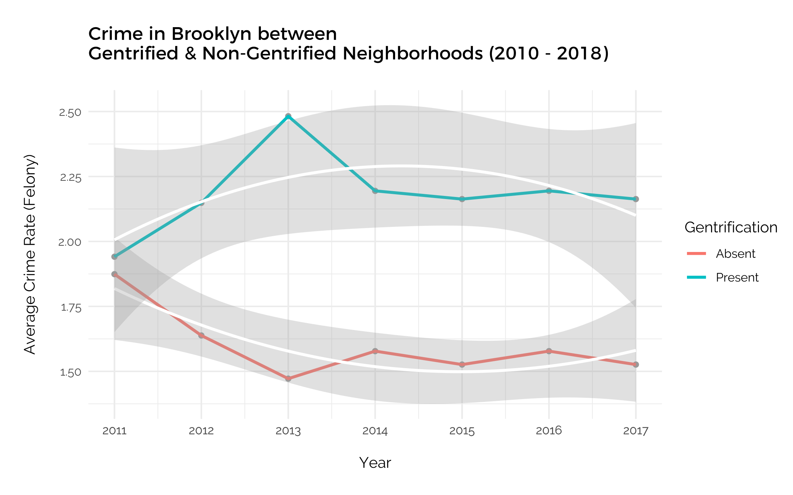

Figure 4: Trend analysis comparison of Felony Crime Rates per Capita between Gentrified and Non-Gentrified neighborhoods for each year from 2010 to 2018.

Dividing the neighborhoods into gentrified and non-gentrified is also affirmed when comparing the average yearly crime rates per capita of these two categories of neighborhoods, as shown in Fig. 4. For neighborhoods with gentrification present, the average felony crime rates increased in 2011 – 2013 from 1.95 to 2.50, decreased in 2013 - 2014 and remained the same after that. For neighborhoods without gentrification, crime rates fell substantially from 1.87 to 1.50, increased slightly from 2013 – 2014 and remained the same after that. Using a quadratic regression line to observe the trend, it is evident that each trend line is distinctly different from the other, suggesting a relation between whether neighborhoods are gentrified or not with crime rates.

While the overall trend is inconclusive and insufficient to conclude the impact of Gentrification on Crime Rates for now, this initial analysis underscores the utility and viability of classifying neighborhoods as Gentrified or Non-Gentrified.

## Hypothesis

Whether or not felony crime rates would increase in Non-gentrified neighborhoods as a result of Gentrification is plausible either way. Based on existing research, it could be reasoned that since Gentrification in a county like Brooklyn would displace residents of low SES (Chapple et al., 2018) into the non-gentrified areas and that since **that low rates of upward mobility coincides with high rates of violent crime (Sharkey, Torrats-Espinosa, 2017), having an influx of more low-income residents in the Non-Gentrified neighborhoods would lead to a rise in felony crime rates. On the other hand, if we were to consider that Gentrification is correlated with falling crime rates in highly Gentrified neighborhoods, as supported by (O’ Sullivan, 2005), it is also possible that this effect ripples to adjacent neighborhoods, thus leading to a decrease in crime rates.**

**Based on the strong influence of Gentrification in Brooklyn, I would presume the latter to be true, in that the impact of Gentrification on lower crime rates in Gentrified neighborhoods would also register in Non-Gentrified neighborhoods, *so crime rates would decrease in non-gentrified neighborhoods.***

**Regardless, the possibility of either happening based on theory is likely, and the more pertinent point is to discover whether or not Gentrification actually has an impact on Crime Rates in Non-gentrified Areas, and how this impact is exerted would be more insightful.**

# Data & Methodology

## **Datasets Imported**

**The main information required for this analysis would be demographic data of Brooklyn neighborhoods to evaluate the extent of Gentrification and the number of Felony crimes committed in the same neighborhood. This was obtained from two datasets:**

### ****A) American Community Survey (ACS) by U.S. Census Bureau****

**Initiated in 2005,** the ACS data that is administered by the U.S. Census Bureau (Bureau, n.d.) **consists of data from annual surveys conducted on approximately 3.5 million households in all U.S. States. This data is aggregated into estimates at geographical summary levels such as states, counties, tracts, etc.**

**A large quantity of data available and only a specific subset of this is required for our analysis. Specifically, demographic data on neighborhoods in Brooklyn over several years is sufficient. Thus, the most efficient way to achieve this is through the Census’ API (Application Programming Interface) accessed with packages in R, such as tidycensus, tigris, choroplethr. The function “get_acs” allows us to obtain only what we need, by specifying the geographical scale (tract), county (Kings), state (NY), year and each variable of interest that is referenced with a unique ID number.**

**For this analysis, the data used are: year, census tract and demographic variables per tract used to evaluate the level of gentrification. The variables of interest used to construct the Gentrification Index include:**

1. **Non-family households (B11010001):   
   This variable estimates the number of householders living alone or with non-relatives only.**
2. **White residents (B03002003):   
   This variable estimates the number of White non-Hispanic or Latino residents in that geographic region for that year.**
3. **Residents without a high school diploma (B06009002):**

**This variable estimates the number of individuals over 25 years and over who are not High School graduates in that geographic region for that year.**

1. **Resident population (B01003001):**

**This variables estimates the number of residents in that geographic region for that year.**

**As mentioned in the 2.1, there is no set definition nor set statistic for Gentrification, so the methodology adopted to define this concept for this paper that is based on Los Angeles’ Index of Neighborhood Change will be explained in** 3.2. **With these selected demographic variables for each Brooklyn neighborhood, it is possible to evaluate the extent of gentrification for that area.**

### ****B) Crime Statistics from the New York Public Safety Department****

**Cases of crime and their details such as location, time of occurrence, level of offense, description of offense, classification IDs, suspect and victim descriptions, are shared through the NYC Open Data platform** (Calgary, n.d.)**. Further descriptions of variables and the dataset are included as well. This dataset is extremely large with 2GB of data and it is useful to first subset only Felony data from Brooklyn. This data is only available from 2010 – 2018 so that limits the study to this time frame.**

**However, the main data required is not immediately available in this dataset. At the highest granularity, what is relevant for the analysis is the number of each type of felonies committed in each census tract or Brooklyn neighborhood per year. Such granularity of analysis is sufficient as the demographic data is only available for each year and neighborhoods are the most appropriate scope to investigate, as explained above. Unfortunately, the data available in the raw dataset only shows the location coordinates of each crime reported and are not aggregated by neighborhoods nor census tracts. Thus, other datasets are required to make the final dataset needed.**

**After the necessary data manipulation, it is possible to compare crime statistics across the years and among the different neighborhoods in Brooklyn. In this way, the impact of gentrification can be observed in these neighborhoods that have not directly experienced gentrification using the Crime statistics over time.**

### ****C) Spatial Compatibility & Manipulation****

**The accessible Census data on Brooklyn delineates the borough into Census Tracts and the NYPD Crime Statistics indicate the specific location of crimes with XY co-ordinates. Hence, two other datasets were required to join the two primary datasets to make the data compatible with one another for subsequent analysis. The sf package in R, which processes the data more quickly than other packages and applications, was utilized for the following steps.**

**Crime: To aggregate Crime statistics into Neighborhood Tract areas, Geospatial JSON data from data.cityofnewyork.us** (*Neighborhood Tabulation Areas*, n.d.) **which comprised Neighborhood Tabulation Areas (NTA), Census Tract numbers and Borough Number is needed. Using the st_join function and setting the join argument as st_within, each crime from the NYPD data was assigned to a neighborhood based on its XY co-ordinate. It was thus possible to calculate the number of Felonies per Neighborhood for each year and conduct spatial analysis solely on Crime statistics.**

**Census & Gentrification: Following, a spatial shape file of all tracts from U.S. Census Bureau with their tract numbers, labeled as GEOID, was required to merge the manipulated** **Census data with this spatial data, such that the Census data with a constructed gentrification index and other demographic variables now have spatial attributes. Spatial analysis then becomes possible on Gentrification Index scores of each of the more than 700 Census tracts in Brooklyn. To obtain both variables in the same dataset at the same granularity, these datasets were merged by GEOID and the corresponding Gentrification scores of each tract were averaged out to apply to each Neighborhood, so it is then possible to analyze Gentrification and Crime by Neighborhood for each year between 2010 – 2018.**

## **Independent Variable: Gentrification**

The level of gentrification in each neighborhood for each year is the independent variable in this analysis and this needs to be defined quantitatively. A simpler Gentrification Index would be established, similar to that of the Los Angeles Index of Neighborhood Change, since their exact methodology and formula is not accessible. With references to the papers reviewed in 2.1.1, the defining metrics that characterize gentrified areas would serve as the metrics used to compute this index. Limited by the datasets available for Brooklyn and for the yearly ACS data, the variables used are the percentage per capita change of the number of white residents (race), number of residents above 25 years without a high school diploma (education), number of non-family householders (family structure) for each of the 50 Brooklyn neighborhoods.

Specifically, since Gentrification refers to a process, the score compares the variables from one year to the previous year. The variables are then computed to reflect the percentage change, that is the percentage change of Number of non-family householders between 2010 – 2018. If the number of foreign-born residents per capita in 2010 is 2.30, and in 2018 is 4.0, the percentage change would be (4.0 – 2.30) / 4.0. The same calculation is applied to the Number of white residents per capita and the Number of non-high school graduates per capita. Then, these three percentage changes are added up, although the value for Number of non-high school graduates per capita would be given a negative coefficient, since having fewer residents who did not complete high school corresponds to an increase in Gentrification, and the other two variables have a positive correlation with Gentrification (Lee, 2003). The final value forms the Gentrification Index score. While it is also possible to include rent and income, this would complicate the aggregation since the percentage change in these variables would not be on the same scale as accounting for the change of number of residents with a certain characteristic per capita. Furthermore, rent as a metric would fail to account for new building developments and residents purchasing their accommodation instead of renting them.

As a result, a Gentrification index score based on those three variables per capita was adopted. It establishes whether a neighborhood is Gentrified or not, and that is mostly sufficient for this paper’s analysis.

## Dependent Variable: Brooklyn Felony Crime Rate

The dependent variable to be evaluated measures the change in Felony Crime Rate per capita in each Brooklyn Neighborhood for each year between 2010 – 2018. The data primarily is sourced from the NYPD Crime Dataset, and only crimes categorized as a Felony are taken into account.

While the intention of using crime rate is to measure criminal activity in the neighborhood, since this is an indicator of a better or poorer quality of life, it also should be noted that many criminal activity can go unreported, or that reporting is more frequent in certain areas as compared to others. Even then, the level of reporting of crime itself is a variable that is informative in an appropriate context.

## Time Frame: 2010 - 2018

Apart from analyzing the relationship between these variables, this research will also involve a study of them through the period of 2010 – 2018. A time series analysis is necessary because such impact on the social well-being of residents can only be observed over a long duration. The specific time frame of the data is selected as it matches the data of the U.S. Census Bureau that is available. Although, as gentrification started since the 1990s, the effects of Gentrification on Crime are not always immediate (McDonald, 1986). Furthermore, some neighborhoods in Brooklyn could have also experienced Gentrification to a high degree such that this evolution would not be reflected in this paper’s Gentrification Index, which only includes variables between 2010 – 2018. Despite that, since most of the Gentrification process in Brooklyn has mostly occurred in the last decade, this time frame is suitable for such a study (Chronopoulos, 2020).

## Control Variables

Control variables that should be considered when evaluating criminal activity in a neighborhood are as follows:

1. Overall New York City Felony Crime Rate   
   If Crime Rate has reduced in the City as a whole, it would be due to stricter NYPD control, anti-crime policies, etc. and not localized to the impact of gentrification on the neighborhood.   
   To account for this, it is only the percentage change in crime rate for each neighborhood from one year and the previous year that is being evaluated and compared to that of other neighborhoods. The actual crime count for each year is not being used in the subsequent overall analysis.
2. Population of the Neighborhood   
   The variables obtained from the Census dataset to construct the Gentrification Index are descriptive indicators of the population which estimate the number of individuals with a certain characteristic. Hence, it is important that the overall population count of the Neighborhood is taken into consideration, as for example, the count of White residents could increase just because the overall population in that Neighborhood has increased, while the racial demographic had remained constant.

This control variable is respected by having all variables be measured per capita, to account for variation in population size.

## Methodology

With all these variables at hand, and after the necessary data cleaning, manipulation and merging of datasets, the main analytical models can be operationalized.

### 3.6.1 Time Series & Multivariate Regression Models

To start out, several regression models were ran to determine the influence of the predictor variables on crime rates only for neighborhoods with negative gentrification scores.

First, a basic Ordinary least squares (OLS) model was ran to investigate the relationship between gentrification score and crime rates. Following, to explore each of the metrics used to construct the Gentrification Index, a multivariate OLS model was ran. Lastly, a regression model controlling for time as a variable was also ran for changes between each individual year, as opposed to the overall time period of 2010 – 2018.

### 3.6.2 Affirming Causal Relationship between Gentrification and Crime

Given that this is a Time-Series Analysis, it is possible that the relationship between Gentrification and Crime could be reciprocal, or that it is in fact Crime Rates that influence the extent of Gentrification, rather than Gentrification having an impact on Crime Rates, as is the focus of this paper. A SEM Cross-lagged Model using the R lavaan package was employed to determine the extent of this reciprocal relationship.

### 3.6.3 Determining Granularity of Research

While it has been stated that Neighborhoods are the level of granularity to review, this decision also comes after exploring the data at the census tract level and at the Neighborhood level in the form of choropleth maps with the Crime rate per capita and Gentrification score variables. It was evident that the choropleth map at the level of Neighborhoods displayed a consistent spread, as opposed to that of census tracts. Even if a higher granularity would provide more details, these details may contain more noise, as evidenced by the boxplot in Fig. 2.1.

With the Gentrification Index used in this paper, it is possible to establish the extent of Gentrification. In addition, upon reviewing the data with the aid of the Text Scatterplot of the neighborhoods by Crime rate and Gentrification score in Fig. 3, it can be observed that the magnitude of the score was not that accurate, especially compared to simply converting this into a binary predictor.

While the data for this analysis covers the time period of 2010 - 2018, it is possible to look at the change between each year, or between 2010 and 2018. Both approaches were attempted and from a series of choropleth maps for both Crime Rates and Gentrification Scores from 2010 - 2011, 2011 - 2012, etc., compared with a choropleth map with variables considering the change between 2010 and 2018, the latter displayed a more coherent story, particularly in neighborhoods of geographical proximity, as shown in Fig. 5.1, 5.2.

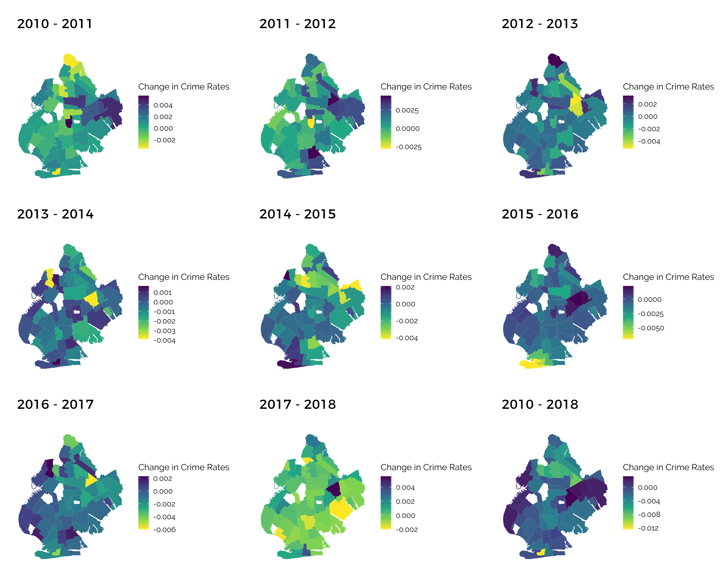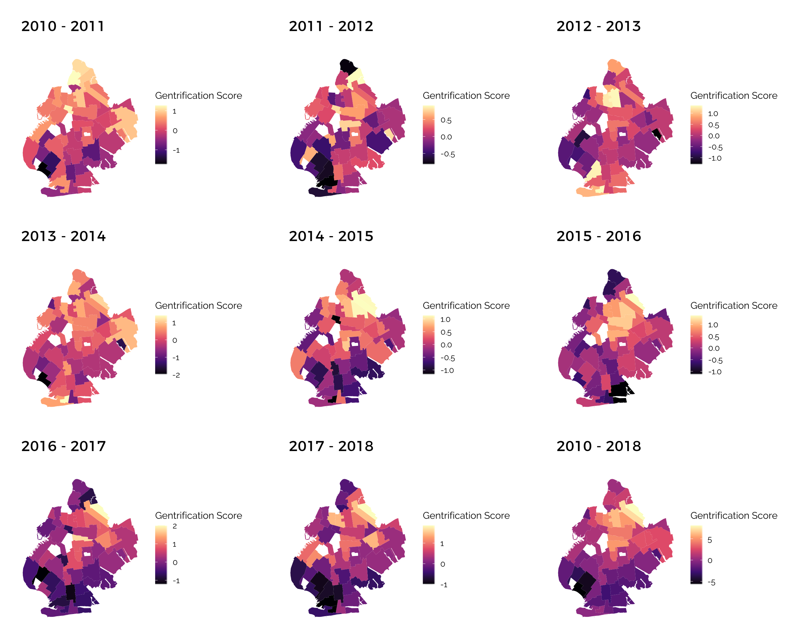

Figure 5.2: Choropleth map of crime rates by neighborhood for each year and from 2010 – 2018

Figure 5.1: Choropleth map of gentrification score by neighborhood for each year and from 2010 – 2018

In addition, the trend analysis carried out as shown in Fig. 4, while useful to demonstrate the significant difference in crime rates between Gentrified and Non-gentrified Neighborhoods, reveals an inconsistent and inexplicable trend in Crime Rates for each year. Evidently, changes between each year are too small to be evaluated, and the overall change in variables are more telling.

### 3.6.4 Identify Non-Gentrified Neighborhoods to Analyze

With a choropleth map analysis of all Neighborhoods according to their Gentrification score from 2010 – 2018, it is evident that the Non-Gentrified Neighborhoods are clustered in the same geographical area.

There were two other outliers with negative gentrification sores, Greenpoint and Brooklyn Heights-Cobble Hill, that can be identified simply by their geographical distance from the other Non-gentrified neighborhoods, and by referencing other research that have shown these two Neighborhoods to have gentrified extensively in the years before 2010.

As such, these two outliers were eliminated from the analysis of Non-gentrified neighborhoods and only the remaining ones were used for further spatial analysis.

### 3.6.5 Spatial Autocorrelation Statistical Models

Finally, a core part of the analysis entails spatial analysis which uses the variables geographic properties. Checking for spatial autocorrelation is helpful since it highlights that each neighborhood is not independent of the other and that the relative outcome of two neighborhoods is related to their distance. For this paper, spatial autocorrelation is in fact assumed, in that the proximity of Gentrified neighborhoods to Non-gentrified neighborhoods would influence Crime rates in the latter.

To detect autocorrelation, the Moran’s I parametric test using Queen contiguity gives a positive or negative spatial autocorrelation score and a p-value for the level of autocorrelation, by weighting the correlation with inverse distances.

Following, Local Indicators of Spatial Association (LISA) becomes useful in providing a statistic for each location with an assessment of significance by establishing a proportional relationship between the sum of the local statistics and a corresponding global statistic. Mapping out any LISA clusters present in the data would provide further insight to spatial autocorrelation, and how Crime Rates are affected due to geographical location.

# Results

## Regression Models

Figure 6.1: Ordinary Least Square regression for Gentrification on Crime rates for non-gentrified neighborhoods (2010 - 2018)

Figure 6.2: Ordinary Least Square multivariate regression for metrics of Gentrification on Crime rates for non-gentrified neighborhoods (2010 - 2018)

Starting out with the basic regression models, the regression model in 6.1 estimates that for every increase in Gentrification score by one unit, the crime rate in non-gentrified neighborhoods decrease by 0.00002, indicating a negative correlation. The intercept shows that when gentrification score is 0, meaning no gentrification, the crime rate decreases by 0.00121, indicating that non-gentrified neighborhoods experience a decrease in crime rates which corresponds to the initial hypothesis and that the less negative the gentrification score of non-gentrified neighborhoods, the lower the crime rates. The coefficient is however not statistically significant but the constant of the intercept is.

When analyzing each of the valuables used to construct the Gentrification index score in Fig. 6.2, every percent increase in white residents per capita leads to a decrease in crime rates by 0.00003, controlling for changes in the percent change in residents without high school diplomas per capita and the percent change in non-family householders per capita. Additionally, a percent lower in residents without high school diplomas per capita leads to a decrease in in crime rates by 0.0001, controlling for the other two metrics. These correspond to the results in Fig 6.1 but the coefficients for percent change in number of non-family householders per capita do not follow the same trend. The coefficients are however not statistically significant.

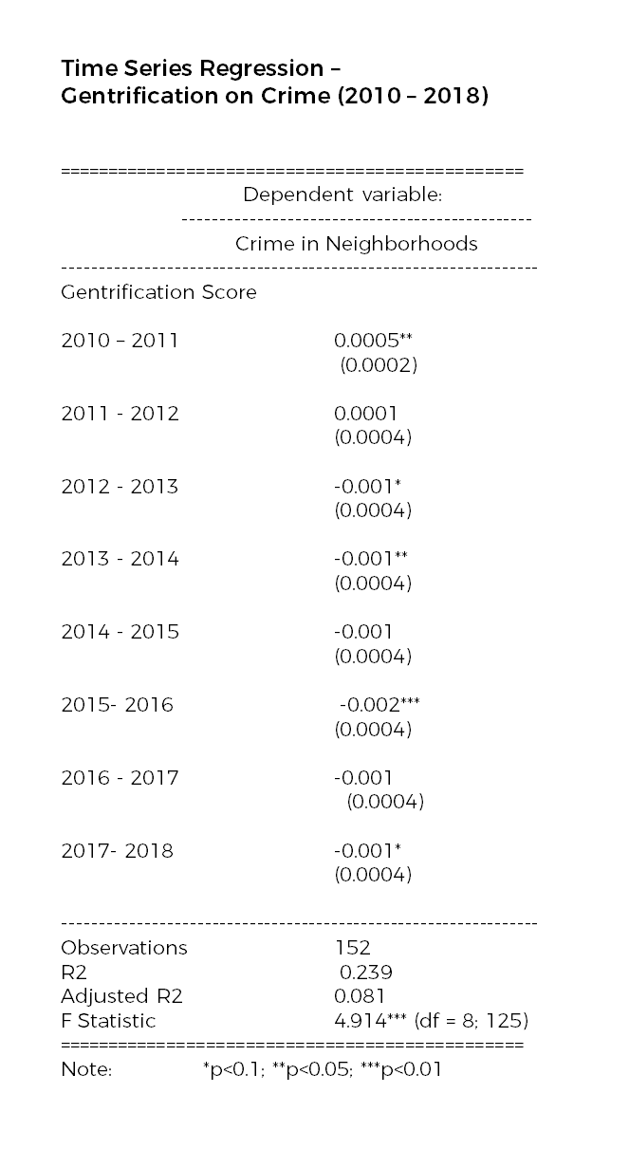

Figure 6.3: Panel regression for Gentrification on Crime rates for non-gentrified neighborhoods for each year between 2010 - 2018

Given that this is a time series analysis, a time series regression model would be more appropriate, meaning that the change of the variables for each year, instead of from the entire period of 2010 – 2018 would be considered as factor variables using the panel linear model (plm) function. From this, shown in Fig 6.3, it can be observed that overall, for every increase in gentrification score among non-gentrified neighborhoods, there is a decrease in crime rate for each year, except in 2010 – 2011 and 2011 - 2012. The results are mostly statistically significant, meaning that they are more reliable in supporting the initial hypothesis.

## Cross-Lagged Model Analysis

To detail the relationship between Gentrification and change in Felony Crime Rates for each neighborhood, the results Cross-Lagged model produced the regression and covariance estimates as shown in this diagram of Fig. 7.

Figure 7: Cross-Lagged Model analysis for Gentrification and Change in Felony Crime Rates. The Beta values of -0.462 for Gentrification on Crime and .0005 for Crime on Gentrification indicates that the former has a stronger effect.

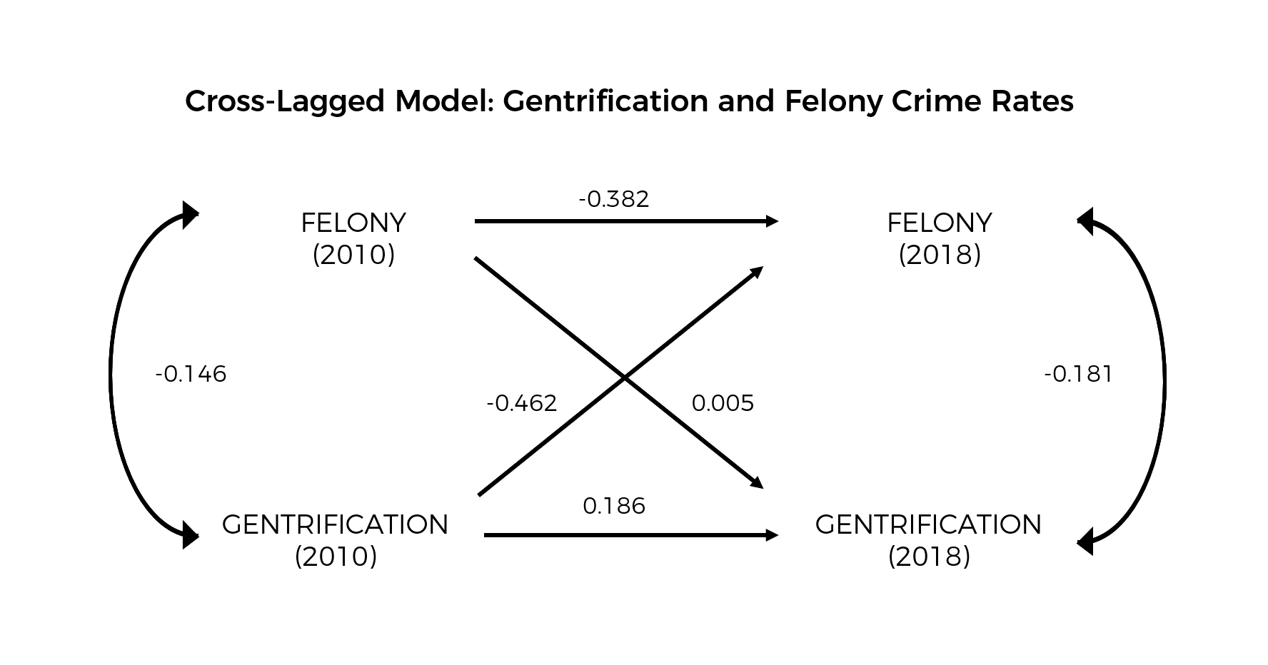

The results show that there is evidence of mutual and reciprocal causation, though the effect of Gentrification on Change in Felony Crime Rates (Beta = 0.462) is 92.4 times stronger than the opposite effect (Beta = 0.005). Hence, this validates that the impact of Gentrification on Crime Rates is relevant for study.

## 4.3 Choropleth Maps

### 4.3.1 All of Brooklyn

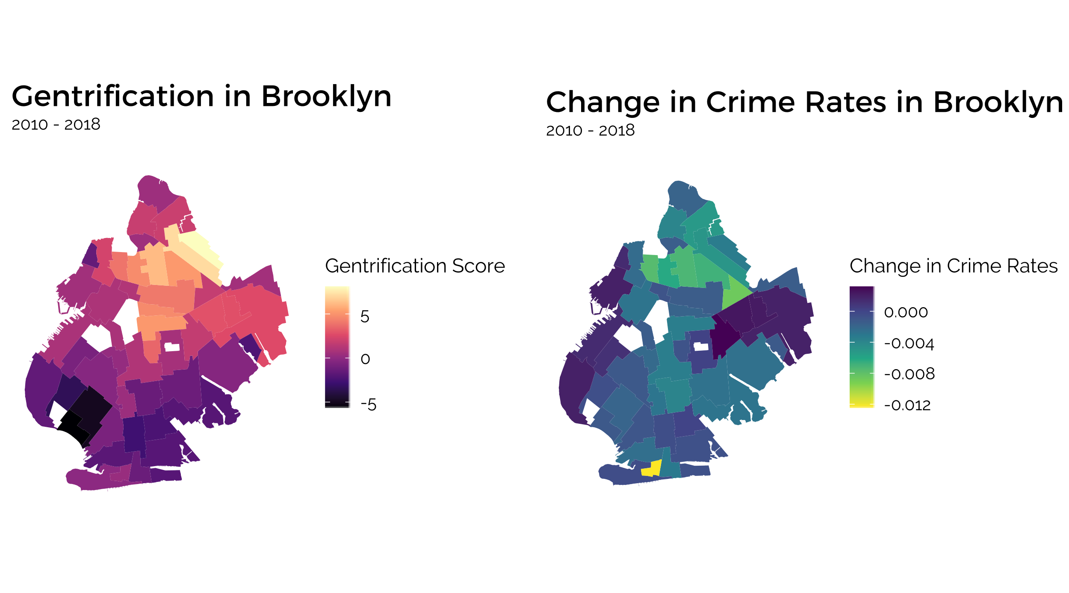Visualizing each variable, Gentrification and Change in Felony Crime Rate, through choropleth maps were helpful in observing spatial correlations between each neighborhood and to affirm the granularity for the analysis. In Fig. 8, the choropleth maps for both variables are shown – the extent of Gentrification is represented in the magma pink palette, where yellow represents a high Gentrification score and dark purple a low Gentrification score. Change in Felony Crime Rates in the viridis turquoise palette indicate higher values in dark blue and lower values in yellow.

Figure 8: Choropleth maps of Gentrification scores and Change in Crime Rate across Neighborhoods in Brooklyn. The maps indicate a spatial relationship for each variable, and also a similarity in spread between both maps.

As can be observed in Fig. 8, there is a general spatial pattern to the distribution, where more gentrified neighborhoods are clustered in the upper-middle portion of Brooklyn, whereas neighborhoods with negative Gentrification scores are located in the lower-middle portion of Brooklyn. Furthermore, the difference between one neighborhood to an adjacent neighborhood is not pronounced, and the gradual spread of colors show that Gentrification levels in neighborhoods are correlated with their adjacent neighborhoods.

This is especially interesting as the same pattern is found in the choropleth map for Change in Crime Rates. Neighborhoods with lower Change in Crime Rates are likewise located in the upper-middle region of Brooklyn, similar to those neighborhoods with higher Gentrification scores. The lower-middle part of Brooklyn shows a higher Change in Crime Rates compared to Gentrified Neighborhoods, although it should be noted that the bulk of these values are still negative, thereby indicating a fall in Crime Rates.

However, the colors on this choropleth map in the lower-middle portion, where Non-Gentrified Neighborhoods are very similar, making it difficult to distinguish the variation in this area. This is mostly because the variation in these neighborhoods is visualized on the same scale as Gentrified Neighborhoods, thus making the difference less pronounced here. Thus, choropleth maps and other analyses focusing on Non-Gentrified Neighborhoods could provide more insight relevant to this paper.

### 4.3.2. Only Non-Gentrified Neighborhoods

Before mapping out the distribution of variables in maps, taking a look at the distribution of the values in this data subset could be useful.

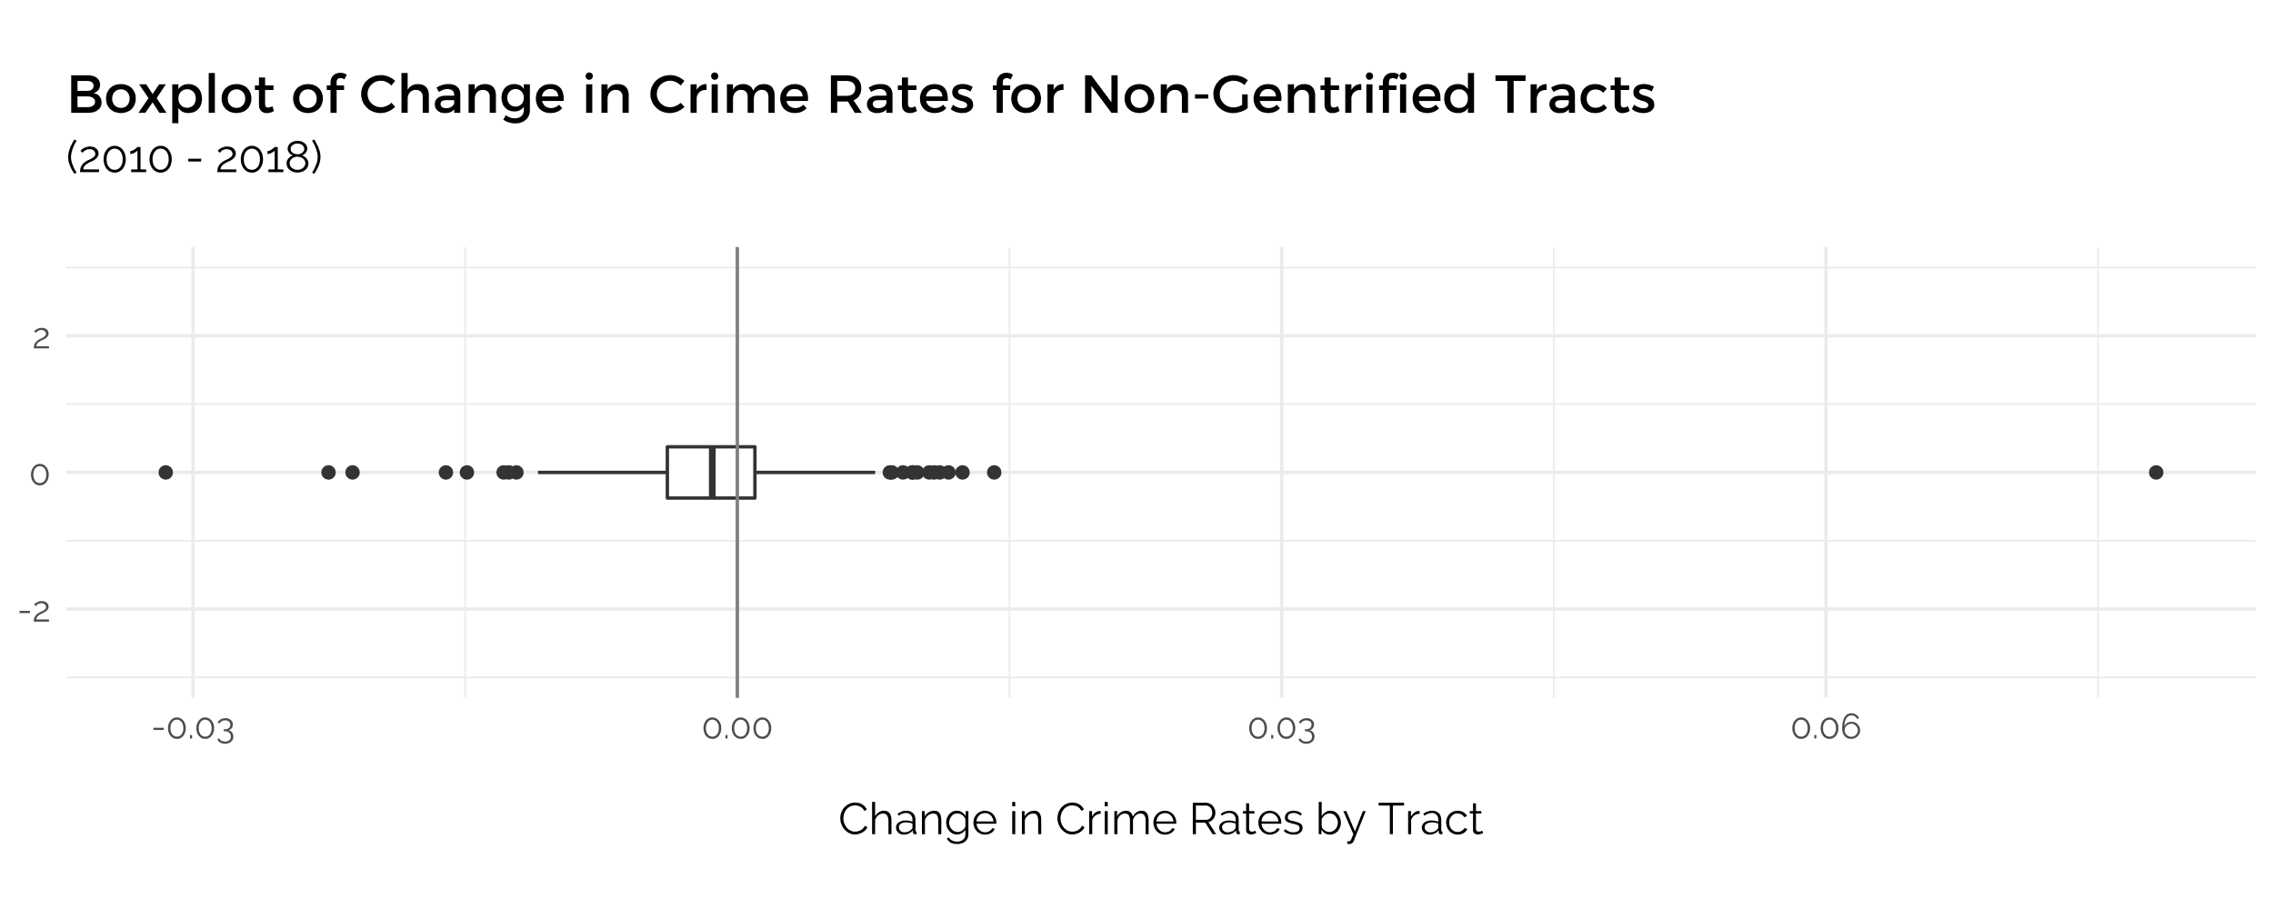

Figure 9.1: Boxplot digram of the Change in Crime Rates for Census Tracts

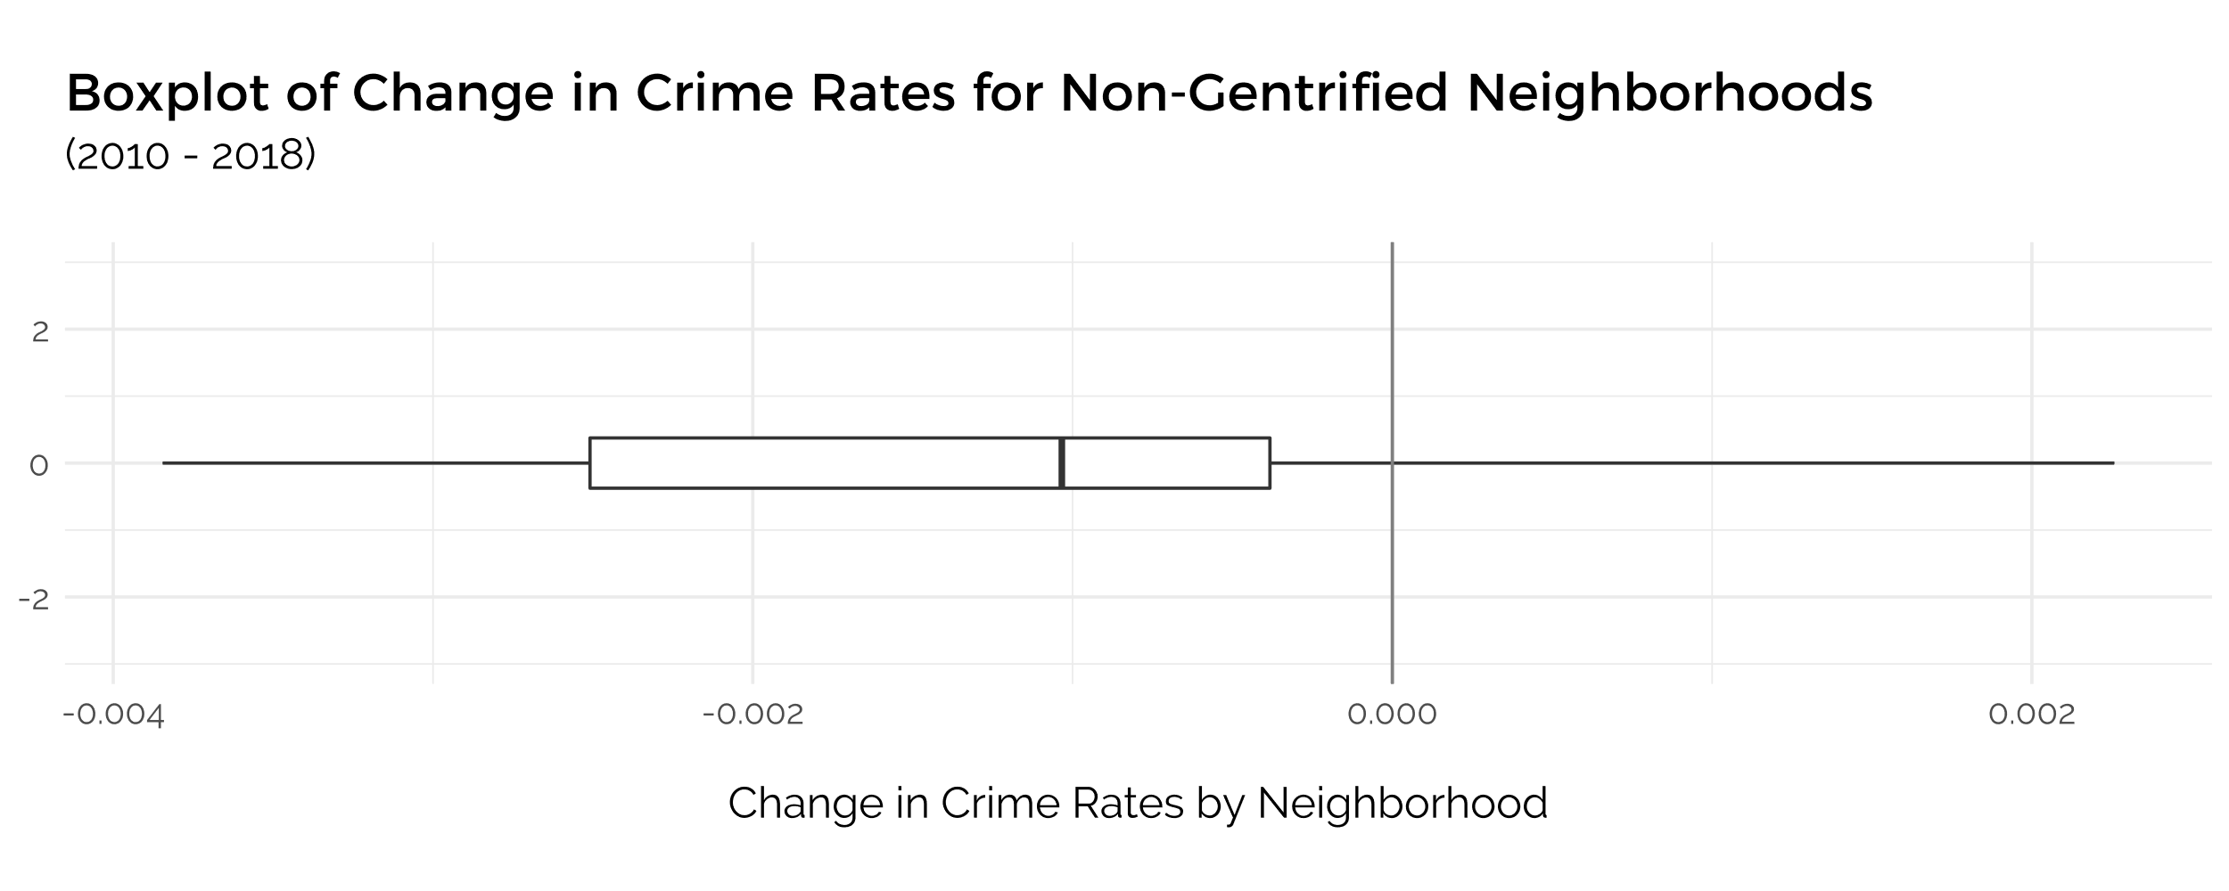

Figure 9.2: Boxplot digram of the Change in Crime Rates for Non-gentrifiedl Neighborhoods



Figure 9.3: Boxplot digram of the Change in Crime Rates for All Neighborhoods

First, the two boxplots of the Change in Crime Rate variable of Non Gentrified neighborhoods are plotted in two different granularities – by Neighborhood and by Census Tracts, to see if there would be any significant difference. Both graphs indicate a mean below 0, suggesting that **in Non-Gentrified Neighborhoods, there is an average decrease in Crime Rates.** In addition, a comparison of both boxplots shows that plotting by Census Tracts produces a lot more outliers than by Neighborhood, thereby affirming the decision to carry out most of the analysis based on Neighborhoods. Furthermore, the boxplot by Neighborhood also indicates that both upper and lower quartiles fall under 0. It is also important to compare this statistic of Change in Crime Rates to that for all neighborhoods (Fig 8.3), where the mean is also negative, and slightly lower than that for Non-Gentrified Neighborhoods.

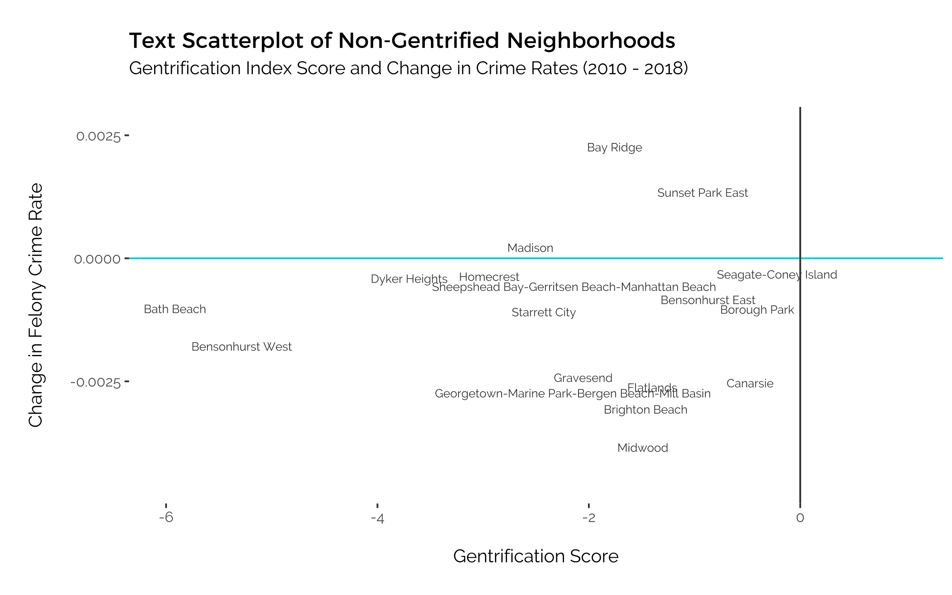

Figure 10: Text scatterplot of only Non-Gentrified Neighborhoods. Most show a decrease in Change in Crime Rates

The same Text scatterplot from above was plotted, though this time with only Non-Gentrified Neighborhoods. This makes it possible to identify exactly which Neighborhoods are anomalies, and to affirm that most of the Non-Gentrified Neighborhoods have experienced a fall in Felony Crime Rates, with the exception of Bay Ridge, Sunset Park East and Madison.

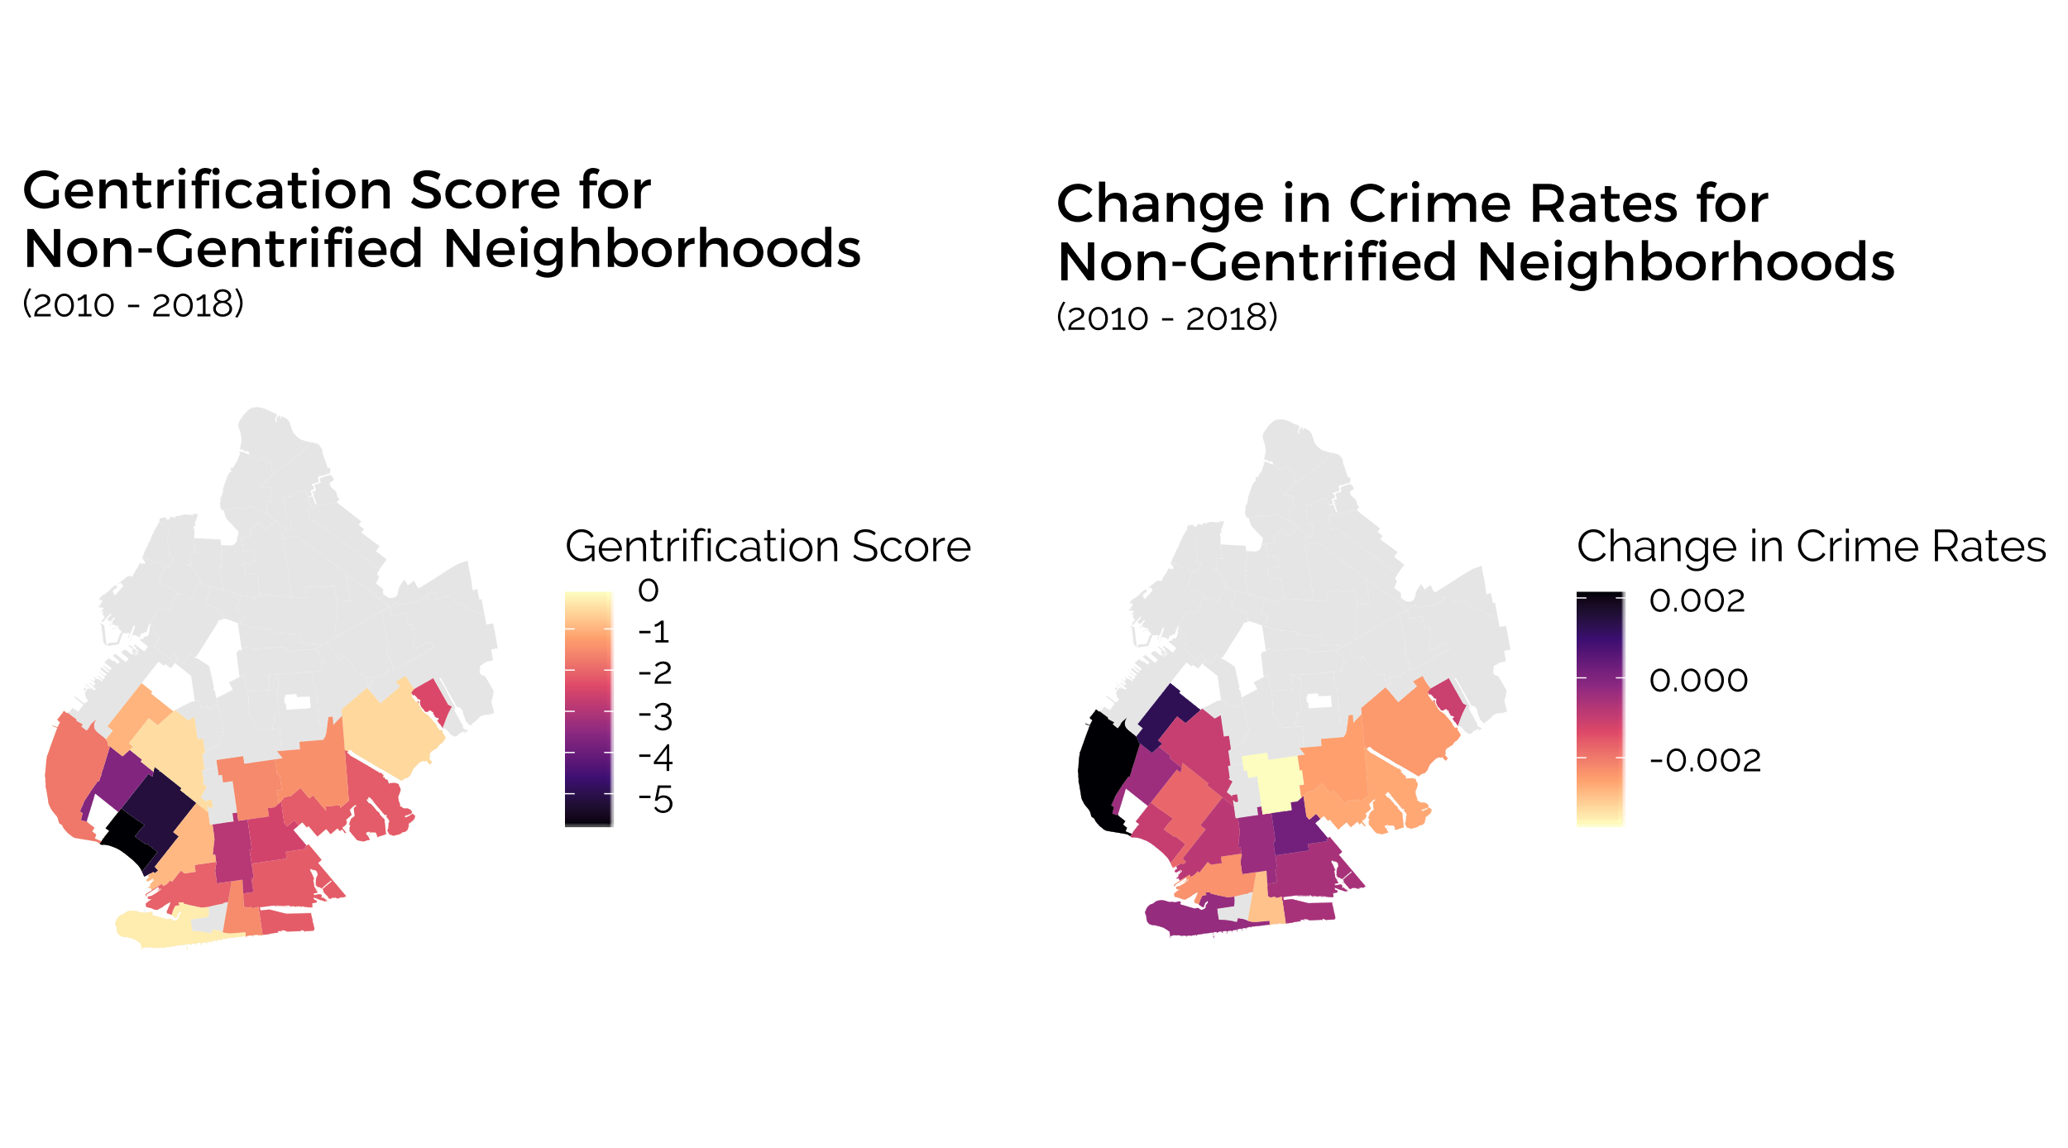

Figure 11. Choropleth Maps comparing the extent of Gentrification and Change in Crime Rates fro Non-Gentrified Neighborhoods

Viewing the distribution of this relationship on choropleth maps would further highlight any spatial relationship present. By only considering Non-gentrified neighborhoods, plotting a choropleth map for the Change in felony crime rates indicate the variation between neighborhoods more clearly. Choropleth maps for both Gentrification scores and Change in crime rates in these Non-gentrified neighborhoods are displayed together in Fig. 11 and with a similar color palette in order to examine the relationship of the spread of both variables.

There are three main observations: first, there is a degree of similarity in how the lighter colors are concentrated in the upper, central and right areas, while the darker colors are found in the bottom-and left neighborhoods. This implies **a relationship of a less negative Gentrification score and a larger decrease in Crime Rates,** similar to the results from the regression models.

Second, the Changes in crime rates also replicate the trends observed earlier, in that most neighborhoods have similar rates as their neighbors, and where almost all the neighborhoods experience a drop in crime rates. However, a spatial trend can be identified - there is also a gradual trend where the neighborhood in the middle has the largest decrease in crime rate and the crime rates increase gradually around it. This suggests that **the crime rates in neighborhoods not bordering Gentrified areas experience a greater decrease in Crime Rates.**

However, the third remark would be that the area on the left, marked by the two neighborhoods in black on the map of Change in Crime Rates, strongly opposes this trend. It has a mild negative gentrification score close to the median, but **they have exceedingly high increases in Crime Rates by comparison.** The exceptions are the neighborhoods on the left-hand side, which spatial autocorrelation models can confirm.

## 4.4 Spatial Autocorrelation Analysis

With some visual evidence that a spatial relationship exists, in order to understand the relationship between the values of Change in Crime Rate in each Neighborhood and the average value in bordering Neighborhoods, the Moran’s Scatterplot is ideal.

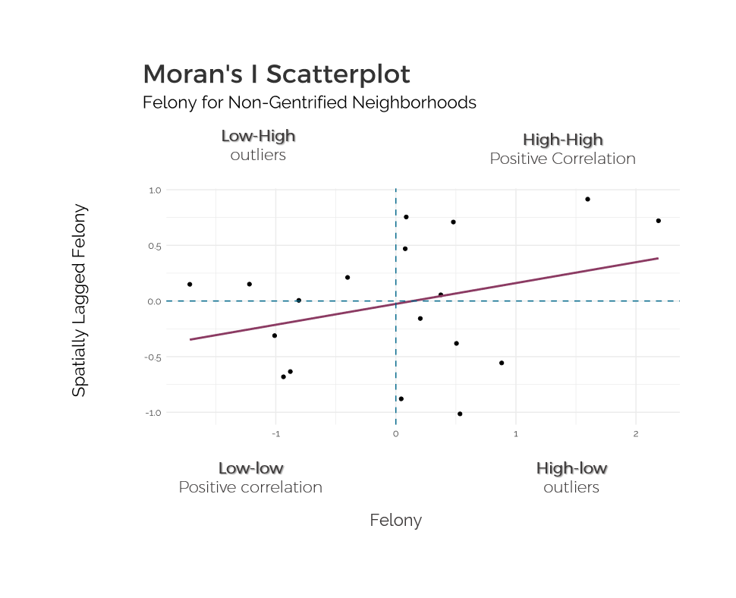

Figure 12: Moran's I Scatterplot analysis for Felony Crime Rates inNon-Gentrified Neighborhoods

The overall slope of the regression line estimating the global Moran’s I indicates that most of the Neighborhoods with high change in crime rate values are surrounded by those with high values as well, and those with low values are surrounded by those with lower values. To observe whether there are significant high-high, low-low, high-low or low-low values, it is best viewed on a Local Indicators of Spatial Association (LISA) Cluster Map.

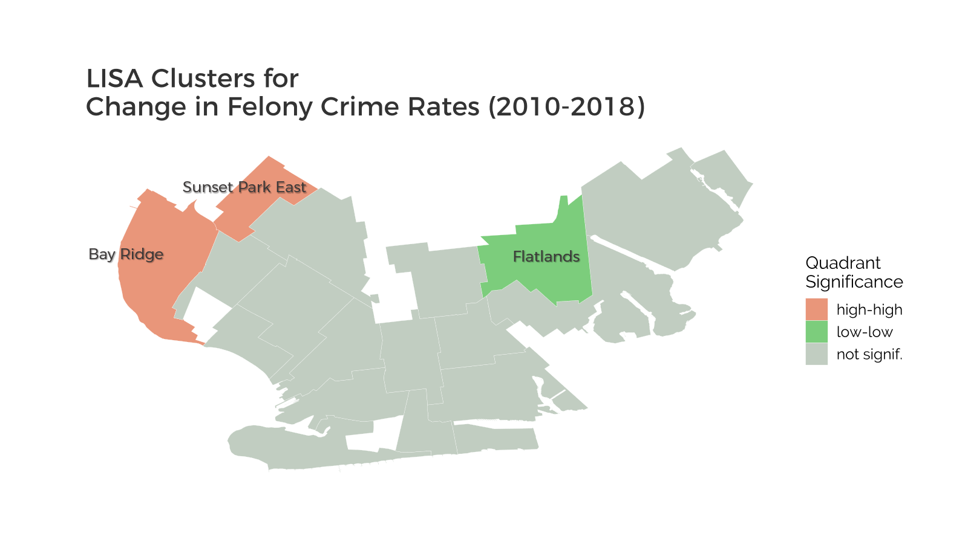

Figure 13: LISA Clusters for Change in Felony Crime Rates of Non-Gentrified Neighborhoods. Four neighborhoods of low-low significance and high-high significance are identified.

The LISA Clusters show a high-high correlation in the neighborhoods on the left, identified as Bay Ridge and Sunset Park East, indicating that both have high values of Change in crime rates as compared to their bordering neighborhoods (Fig. 13). These two neighborhoods were also the outliers identified above that opposed the trend of how less negative gentrification scores correspond to lower crime rates. To further understand these exceptions, a deeper analysis into the Change in crime rate across the different types of Felonies could prove useful.

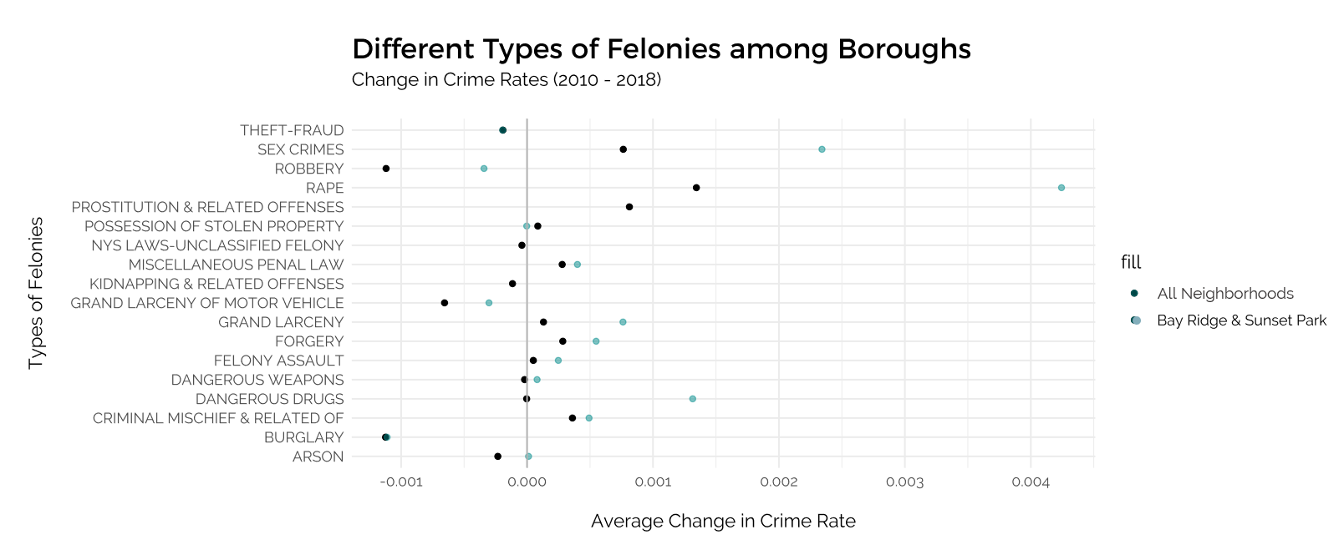

While a Felony is already a category of crime that makes reference to the severity of the offence, there still are a range of felonies. In the distribution plot above, the average Change in crime rates for the two outliers of Bay Ridge & Sunset Park are compared with the average values for all neighborhoods. The increase in Change in Crime Rates for the outliers are especially high for sex crimes, rape, robbery, grand larceny, dangerous drugs. This informs of how exactly Crime in those two neighborhoods are evolving with respect to all the other neighborhoods.

# Discussion

## Significance of Results for Gentrification on Crime

From the results obtained and the subsequent analysis, several conclusions about Gentrification in Brooklyn can be drawn.

Firstly, **Gentrification has an impact on Crime throughout time**, as demonstrated in the cross-lagged model analysis (Fig. 7). This relationship has been discussed in research (Ellen, 2019), where some hypothesize that it is Crime which determines the extent of Gentrification, but the results from this analysis proves contrary. Establishing this then provides more credibility and significance for the subsequent findings.

Following, the spatial relationships for each of the variables were explored through choropleth maps, where **a presence of spatial dependence can be observed** (Fig. 8). Certain areas, in the upper portion of Brooklyn, had significantly lower Gentrification and Change in Crime Rates. These include neighborhoods of Bedford, Stuyvesant Heights, Clinton Hill, and Bushwick South. It corresponds to existing reports about how these areas have recently undergone high levels of gentrification (Donnelly, 2018), especially compared to neighborhoods on the top and left, such as Williamsburg, DUMBO, Brooklyn Heights, or Greenpoint. On the other hand, the more southern neighborhoods of Brooklyn have distinctly lower and negative Gentrification scores, indicating the lack of Gentrification, as measured by the Gentrification Index used in this paper. The neighborhoods with the most negative Gentrification scores include Bensonhurst West, Bath Beach, and Dyker Heights, where the surrounding neighborhoods also reflect similar low scores of Gentrification. Change in felony rates are slightly higher than it is in the more northern parts of Brooklyn, though it is mostly negative.

A closer look into only Non-Gentrified Neighborhoods, which comprise almost half of the Brooklyn neighborhoods, provides a more comprehensive understanding of these areas. It is in these areas that data and research is relatively lacking but having access to the city’s datasets makes it possible to learn more about these areas by using the few datasets available here in combination with data from surrounding areas.

Viewing the distribution of the Change in crime rate values through boxplot diagrams for Non-gentrified neighborhoods and all Neighborhoods confirms that both means are negative, though it is lower for all Neighborhoods than it is for Non-gentrified neighborhoods. This indicates that there is a decrease in Change in crime rate for Non-gentrified neighborhoods, but to a lower extent than when considering this statistic for all of Brooklyn. The decrease thus adheres to the overall trend and comparing it to the overall trend puts it in perspective that the decrease is not an anomaly or particularly significant. Additionally, Fig. 10 confirms the overall decreasing Felony Crime Rates in Non-Gentrified Neighborhoods, with only Bay Ridge, Sunset Park East and Madison experiencing increasing rates, although Madison’s is relatively closer to zero.

By exploring the relationship between both Gentrification and Crime variables in Non-Gentrified Neighborhoods through a linear regression, it is observed that a less negative Gentrification Score (i.e. closer to being considered as undergoing Gentrification) corresponds to a higher decrease in Felony crime rates (i.e. Crime is decreasing at a greater rate than others). This extends the conclusion that while neighborhoods in non-gentrified areas of Brooklyn have experienced, on average, decreasing Felony crime rates, those that are closer to gentrified neighborhoods experience even greater decreasing crime rates.

This trend is also reflected upon comparison of two choropleth maps of Gentrification and Change in Crime Rates for only Non-Gentrified Neighborhoods (Fig. 11), where the colors are lighter in the middle, and it gradually becomes darker towards the exterior parts. The exterior parts are also the ones closer to Gentrified Neighborhoods, suggesting that Gentrification could lead to an increasing decrease in Crime Rates in the bordering Neighborhoods that have not undergone Gentrification. Two outliers contradict this trend – Bay Ridge and Sunset Park West, which have a Gentrification score closer to zero but a higher increase in Crime Rate. Referencing the Text Scatterplot above for only Non-Gentrified areas, these two neighborhoods are the ones with highest Change in Crime Rates, out of the three neighborhoods with a positive rate.

Upon checking for spatial outliers, the Moran’s I Scatterplot indicates that there are insignificant low-high and high-low values and the global trend still holds a positive correlation between Spatially Lagged Change in Felony Crime Rate values and the original values (Fig. 12). However, the LISA Cluster Map identifies neighborhoods that have exceptionally high-high and low-low relationships. Unsurprisingly, Bay Ridge and Sunset Park West are once again identified as an outlier, having a significant high-high relationship.

## Understanding Outliers

With such outstanding outliers, it seemed important to further discern the reason behind these, if any; they could be statistical outliers, or this could provide more revelations.

Referencing existing literature and news reports, it appears that these two neighborhoods, Bay Ridge and Sunset Park West, are beginning to gentrify (Fauconnet, 2020) (Badger, 2017). There are new developments and buildings being constructed, but the population has not yet changed too much, thereby explaining the still negative Gentrification Index Score. Still, current residents are beginning to get displaced.

This paper (Ellen, 2019) also surmises that in areas where Gentrification is starting to occur, and where there is an amalgamation of original and new residents of higher SES, crime rates increase. This is explained by having more crimes reported, higher vigilance of police officers, and having more opportunities for criminal activity.

To further explore this reasoning, the Change in crime rates for the different types of Felonies for these two neighborhoods were compared with that of all neighborhoods, to investigate whether there is a significant increase in certain types of crime. The increase of sex crimes, rape, grand larceny, dangerous drugs, and robbery were found to be significantly higher than the overall Brooklyn average. This corresponds to the rise in robbery and larceny observed in newly gentrifying neighborhoods during the 1970 (Covington, 1989) which could suggest that these crimes are more common in neighborhoods that are beginning to gentrify.

## Limitations of Research

### 5.3.1. Defining Gentrification

The most subjective part of this study would be defining gentrification since there are several ways to do so. Even with referencing existing work done on this, the concept is still abstract and quantifying the extent of this process would never be completely accurate. While the simplified Gentrification index score used here for Brooklyn is mostly sufficient for identifying non-gentrified neighborhoods and analyzing the change in crime rates, more indicators could be used from other datasets to improve this definition.

### 5.3.2. Crime Rates = Criminal Activity?

As mentioned above, the Felony crime rates used to evaluate the transformation of each neighborhood based on the Gentrification scores were calculated based on the number of felonies for that time period and area from the official NYPD data. It should be noted that these include the complaints and police investigations, not actual criminal activity. Both are quite different since criminal activity reflects the standard of living in that area, whereas reported crime is influenced by how likely residents would report crime and how much police surveillance there is.

Referencing the outliers of Bay Ridge and Sunset Park East, even though they had gentrification scores close to zero, crime rates were increasing relatively significantly. These are the areas where gentrification is only starting to happen and they currently host both original residents and new, incoming residents. Ellen’s paper on Gentrification hints at how there are “increasing opportunities for property crime in the short term” but also more reporting and more pressure on the police (Ellen, 2019). Furthermore, lower-income families in non-gentrified areas “have more experience or confidence in their ability to navigate crime”, suggesting that even though criminal activity may be high, this is not always reported.

### 5.3.3. Scale: Time Period, Geography

While this study is limited to the period of 2010 – 2018 because of the availability of Crime rate data, research over a longer period could shed more light on the relationship between gentrification and crime. Gentrification is a long and slow process so more data over the years would improve the reliability of the study.

Similarly, this study is limited to Brooklyn, largely because of how influential Gentrification is in the area. However, as Gentrification is present in cities all over the world, further studies on the relationship between Non-gentrified areas and Crime would be insightful.

### 5.3.4. Other Confounder Variables

Other variables that could have been used as control variables would include factors aside from gentrification that may affect crime rates during those years. This could include policies directed at certain neighborhoods with high crime rates, increase or decrease in gang activity that is present in a certain neighborhood, etc. These were not available in the datasets used, since they refer to very specific situations. Still, they could significantly impact Crime rates in certain neighborhoods.

## 

# Conclusion

Overall, it is possible to understand the impact of Gentrification on less-studied Non-Gentrified Neighborhoods using crime data that is available consistently throughout New York. This highlights the importance of having such quantitative public datasets to be freely accessible, so that researchers may explore non-obvious relationships and provide more insight to less-researched areas in an economical way, in the context of Urban Planning.

The relationship between Gentrification and Crime in Non-Gentrified Neighborhoods in Brooklyn can be summarized as follows:

Non-gentrified neighborhoods of Brooklyn which are located mostly in the south (with the exception of Coney Island) experience an overall fall in Felony crime rates, though to a lower extent than the whole of Brooklyn. There is also a trend of neighborhoods which are less non-gentrified having a larger decrease in crime rates, and this is especially so in neighborhoods bordering Gentrified areas. However, two neighborhoods, Bay Ridge and Sunset Park West, distinctly oppose this trend. Identifying these outliers led to further research into these specific areas which suggest that in areas that are starting to gentrify and have a mixture of original and new residents, crime rate increases, likely due to both higher criminal activity but also more reporting.

Overall, the modern definition of Gentrification is an urban process that is increasingly present throughout the world, with Brooklyn being an area that has experienced several waves of Gentrification since the 1990. This evolution is arguably one of the most significant socio-economic changes to the region, thereby reducing external variables and thus making it accurate to understand the social impact of gentrification on non-gentrified neighborhoods, not just in this borough, but perhaps in other cities globally.

# References

1. Affairs, U. N. D. of E. and S. (2019). *World Urbanization Prospects: The 2018 Revision*. United Nations. <https://doi.org/10.18356/b9e995fe-en>
2. *Affordable housing coming to Sunset Park*. (n.d.). Retrieved January 6, 2021, from <https://brooklyneagle.com/articles/2020/11/12/affordable-housing-coming-to-sunset-park/>
3. Badger, E. (2017, January 5). How to Predict Gentrification: Look for Falling Crime (Published 2017). *The New York Times*. <https://www.nytimes.com/2017/01/05/upshot/how-to-predict-gentrification-look-for-falling-crime.html>
4. Barton, M. S. (2016). Gentrification and Violent Crime in New York City. *Crime & Delinquency*, *62*(9), 1180–1202. <https://doi.org/10.1177/0011128714549652>
5. Bureau, U. C. (n.d.-a). *American Community Survey (ACS)*. The United States Census Bureau. Retrieved September 10, 2020, from <https://www.census.gov/programs-surveys/acs>
6. Bureau, U. C. (n.d.-b). *TIGER/Line Shapefiles*. The United States Census Bureau. Retrieved September 5, 2020, from <https://www.census.gov/geographies/mapping-files/time-series/geo/tiger-line-file.html>
7. Calgary, O. (n.d.). *NYC crime | NYC Open Data*. Retrieved September 10, 2020, from <https://data.cityofnewyork.us/Public-Safety/NYC-crime/qb7u-rbmr>
8. Chronopoulos, T. (2020). “What’s Happened to the People?” Gentrification and Racial Segregation in Brooklyn. *Journal of African American Studies*, *24*(4), 549–572. <https://doi.org/10.1007/s12111-020-09499-y>
9. Cohen, M., & Pettit, K. L. S. (n.d.). *GUIDE TO MEASURING NEIGHBORHOOD CHANGE TO UNDERSTAND AND PREVENT DISPLACEMENT*. 32.
10. Covington, J., & Taylor, R. (1989). Gentrification and Crime: Robbery and Larceny Changes in Appreciating Baltimore Neighborhoods During the 1970s. *Urban Affairs Review*, *25*, 142–172. <https://doi.org/10.1177/004208168902500109>
11. *Criminal Justice Process—NYPD*. (n.d.). Retrieved January 5, 2021, from <https://www1.nyc.gov/site/nypd/services/victim-services/glossary.page>
12. Ellen et al. *- Has Falling Crime Invited Gentrification.pdf*. (n.d.-a). Retrieved January 5, 2021, from <https://furmancenter.org/files/Has_Falling_Crime_Invited_Gentrification_FINAL.pdf>
13. Ellen, I. G., & Torrats-Espinosa, G. (2019). Gentrification and Fair Housing: Does Gentrification Further Integration? *Housing Policy Debate*, *29*(5), 835–851. <https://doi.org/10.1080/10511482.2018.1524440>
14. *International Encyclopedia of Housing and Home | ScienceDirect*. (n.d.). Retrieved February 13, 2020, from <https://www.sciencedirect.com/referencework/9780080471716/international-encyclopedia-of-housing-and-home>
15. Lees, L. (2003). Super-gentrification: The Case of Brooklyn Heights, New York City. *Urban Studies*, *40*(12), 2487–2509. <https://doi.org/10.1080/0042098032000136174>
16. *Los Angeles Index of Neighborhood Change*. (n.d.). Retrieved January 5, 2021, from <https://www.arcgis.com/home/item.html?id=57e9231c3bd34d44ae49b309b0cb440e>
17. *Mapping Displacement and Gentrification in the New York Metropolitan Area | Urban Displacement Project*. (n.d.). Retrieved December 3, 2020, from <https://www.urbandisplacement.org/maps/ny>
18. McDonald, S. C. (1986). Does Gentrification Affect Crime Rates? *Crime and Justice*, *8*, 163–201. <https://doi.org/10.1086/449122>
19. Mordechay, K., Ayscue, J. B., & Orfield, F. G. (n.d.). *School Integration in Gentrifying Neighborhoods:* 53.
20. *Neighborhood Tabulation Areas (Formerly “Neighborhood Projection Areas”)*. (n.d.). Retrieved September 10, 2020, from <https://www1.nyc.gov/site/planning/data-maps/open-data/dwn-nynta.page>
21. O’Sullivan, A. (2005). Gentrification and crime. *Journal of Urban Economics*, *57*(1), 73–85. <https://doi.org/10.1016/j.jue.2004.08.004>
22. *Part_1_Gentrification_SOCin2015_9JUNE2016.pdf*. (n.d.). Retrieved January 4, 2021, from <https://furmancenter.org/files/sotc/Part_1_Gentrification_SOCin2015_9JUNE2016.pdf>
23. Sharkey, P., & Torrats-Espinosa, G. (2017). The effect of violent crime on economic mobility. *Journal of Urban Economics*, *102*, 22–33. <https://doi.org/10.1016/j.jue.2017.07.001>
24. *The Gentrifier’s Dilemma: Narrative Strategies and Self‐Justifications of Incoming Residents in Bedford‐Stuyvesant, Brooklyn—Donnelly—2018—City &amp; Community—Wiley Online Library*. (n.d.). Retrieved January 5, 2021, from <https://onlinelibrary.wiley.com/doi/full/10.1111/cico.12296?casa_token=AVp_tC4DzVoAAAAA%3Ax-qygMJmRA4wMLqdiedPku_jiTPO2f8oT_aaQQTC0o_1MoVuOc4b814IkC0KyZqtFJzogz7amZNSHjo>
25. Yee, V. (2015, November 27). Gentrification in a Brooklyn Neighborhood Forces Residents to Move On (Published 2015). *The New York Times*. <https://www.nytimes.com/2015/11/29/nyregion/gentrification-in-a-brooklyn-neighborhood-forces-residents-to-move-on.html>